# PROJECT DESIGN PHASE II

**DATA FLOW DIAGRAMS AND USER STORIES**

|  |  |
| --- | --- |
| **TEAM ID** | PNT2022TMID14121 |
| **PROJECT NAME** | Inventory Management System for Retailers |
| **MAXIMUM MARKS** | 4 Marks |

# Data Flow Diagrams:

A Data Flow Diagram (DFD) is a traditional visual representation of the information flows within a system. A neat and clear DFD can depict the right amount of the system requirement graphically. It shows how data enters and leaves the system, what changes the information, and where data is stored.

# DATA FLOW DIAGRAM

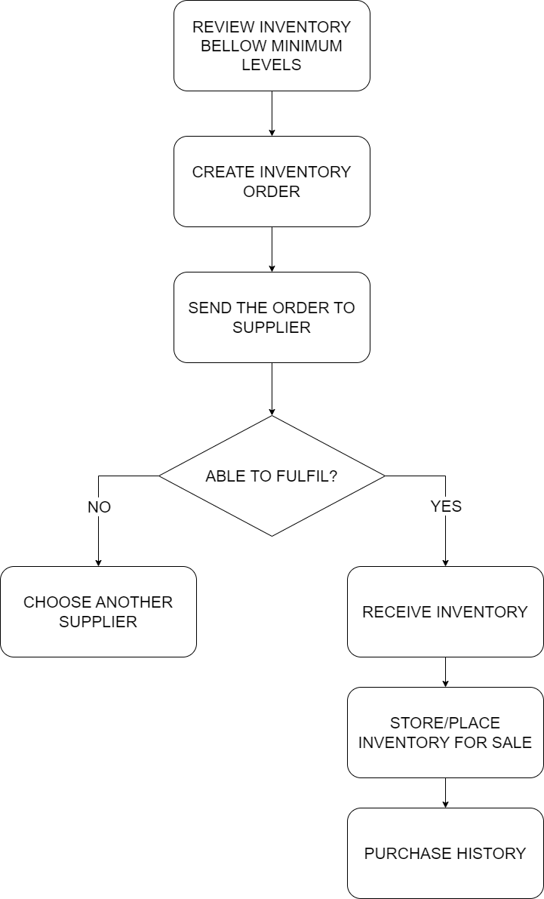

**USER STORIES:**

Use the below template to list all the user stories for the product.

|  |  |  |  |  |  |  |
| --- | --- | --- | --- | --- | --- | --- |
| **User Type** | **Functional Requirement (Epic)** | **User Story Number** | **User Story/Task** | **Acceptance criteria** | **Priority** | **Release** |
| **Customer (Mobile user)** | Registration | USN-1 | As a user, I can register for the application by entering my email, password, and confirming my password. | I can access my account / dashboard | High | Sprint-1 |
|  |  | USN-2 | As a user, I will receive confirmation email once I have registered for the application | I can receive confirmation email & click confirm | High | Sprint-1 |
|  |  | USN-3 | As a user, I can register for the application through Facebook | I can register & access the dashboard with Facebook Login | Low | Sprint-3 |
|  |  | USN-4 | As a user, I can register for the application through Gmail | I can register for the application through Gmail | Medium | Sprint-2 |
|  | Login | USN-5 | As a user, I can log into the application by entering email & password | I can log in by entering Gmail & password | High | Sprint-1 |
|  | Dashboard | USN-6 | As a user, I can track data of sales of products and inventory levels | I can track data of sales of products and inventory levels. | High | Sprint-1 |
| **Customer (Web user)** | Registration | USN-7 | As a user, I can register for the application by entering my email, password, and confirming my password. | I can access my account / dashboard | High | Sprint-1 |

|  |  |  |  |  |  |  |
| --- | --- | --- | --- | --- | --- | --- |
|  |  | USN-8 | As a user, I will receive confirmation email once I have registered for the application | I can receive confirmation email & click confirm | High | Sprint-1 |
|  |  | USN-9 | As a user, I can register for the application through Facebook | I can register & access the dashboard with Facebook Login | Low | Sprint-3 |
|  |  | USN-10 | As a user, I can register for the application through Gmail | I can register for the application through Gmail | Medium | Sprint-2 |
|  | Login | USN-11 | As a user, I can log into the application by entering email & password | I can log in by entering Gmail & password | High | Sprint-1 |
|  | Dashboard | USN-12 | As a user, I can track data of sales of products and inventory levels | I can track data of sales of products and inventory levels. | High | Sprint-1 |
| **Customer Care Executive** | Support | USN-13 | As a Executive, I Provide answers for the queries asked by users | I provide the answers for the queries asked by the users. | High | Sprint-1 |
| **Administrator** | Manage the Stocks | USN-14 | As a administrator, I manage the stocks by adding, shipping and storing the stocks in the storage units | I manage the stocks by adding, shipping and storing the stocks in the storage units. | High | Sprint-1 |
|  | Control all the users | USN-15 | As an administrator, I can control all the users by performing basic CRUD operations. | I can control all the users by performing basic CRUD operations | High | Sprint-1 |
|  | Access the database | USN-16 | As a administrator, I can control and access the database | I can control and access the database. | High | Sprint-1 |